General:

FONT: I would only use Regular 400, Medium 500, and Black 900 styles from the Poppins font. Now there are too many different styles. No more than 3 is a good amount.

COLORS: #FEB449 Orange is the interaction color. This should be constant (hovering state). #313133 dark gray is the other main color. (buttons when there is no interaction)

PADDINGS: Padding should be constant on all buttons.

SHADINGS: Should be constant across the website.

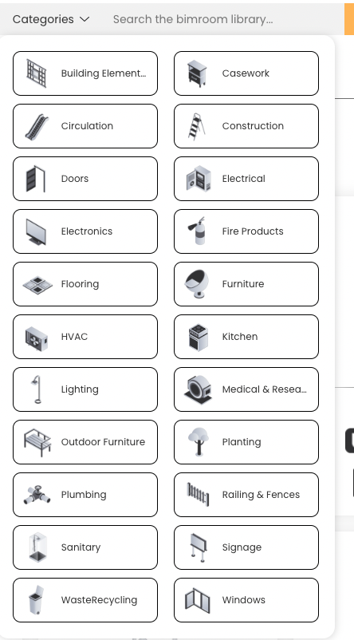

3. Corner roundness? Is this constant through the webpage? Borders are black here, but not in other parts → maybe just shading & more shading when hovering?

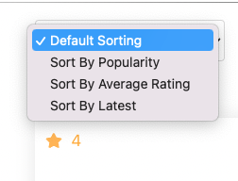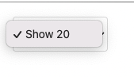

4. Looks very out of context (UI is forgotten from this drop down menu) Should look the same as the point 3. (all drop down menus the with the same style)

* I think this comes with Safari, is there are a way of making this look like the one on Chrome

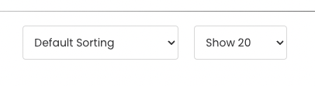

5. The arrow is very close to the border. Too big gap between text and arrow → makes button wider than needed. Also should not be any thin border lines but just shading as in other buttons in the design.

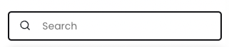

7. No borders here, since it is not part of the design, just shading behind the button.

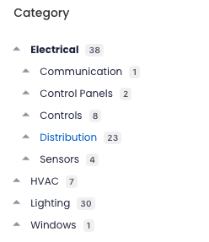

8. Hovering color darker black (or orange if readibilty stays) Blue is out of context. I would also make this menu a bit bigger(bigger font size, since there is room in the tab). It is quite hard to see. Also, the arrows are not making sense, should be more clear what products are under Electrical for example.



here hovering makes orange background and white text. This should be constant.

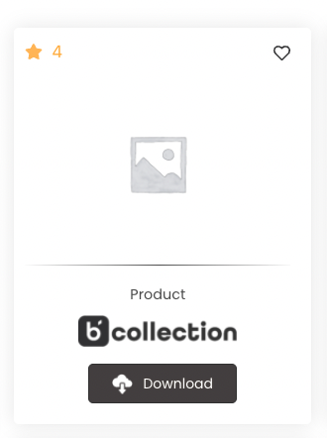9. Decide on a constant shading for the default state and add shading when hovering with the mouse.

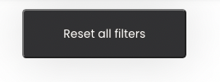11. Too big button, less padding needed.

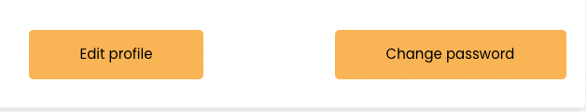

13. These buttons could be gray with a hovering state of orange & white text.

The profile picture could be bigger to avoid unnecessarily empty space.

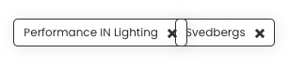14. When filters are added they appear on top, but overlap, that doesn’t look good → should not overlap. Also here I would replace thin black borders with button shading.

 16. These icons could also have the interaction color orange, when hovering.

17. Different stroke sizes between icos → make stroke size constant.

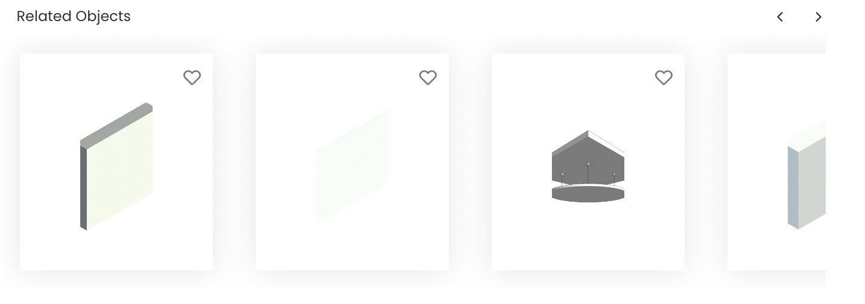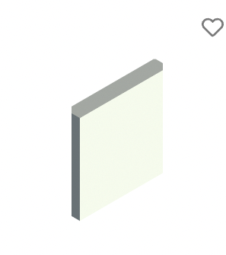18. Here is no indication of what these objects are(text needed).

19. Do the upper corners have the same corner radius as other buttons? Looks more round… Also here white is an interaction color and the text is black and bold. This is different than in the main page where orange is the interaction color and otherwise tabs are dark gray. I would make one design choice and stick with that.

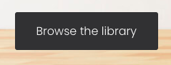 20. Here again is a different corner radius.

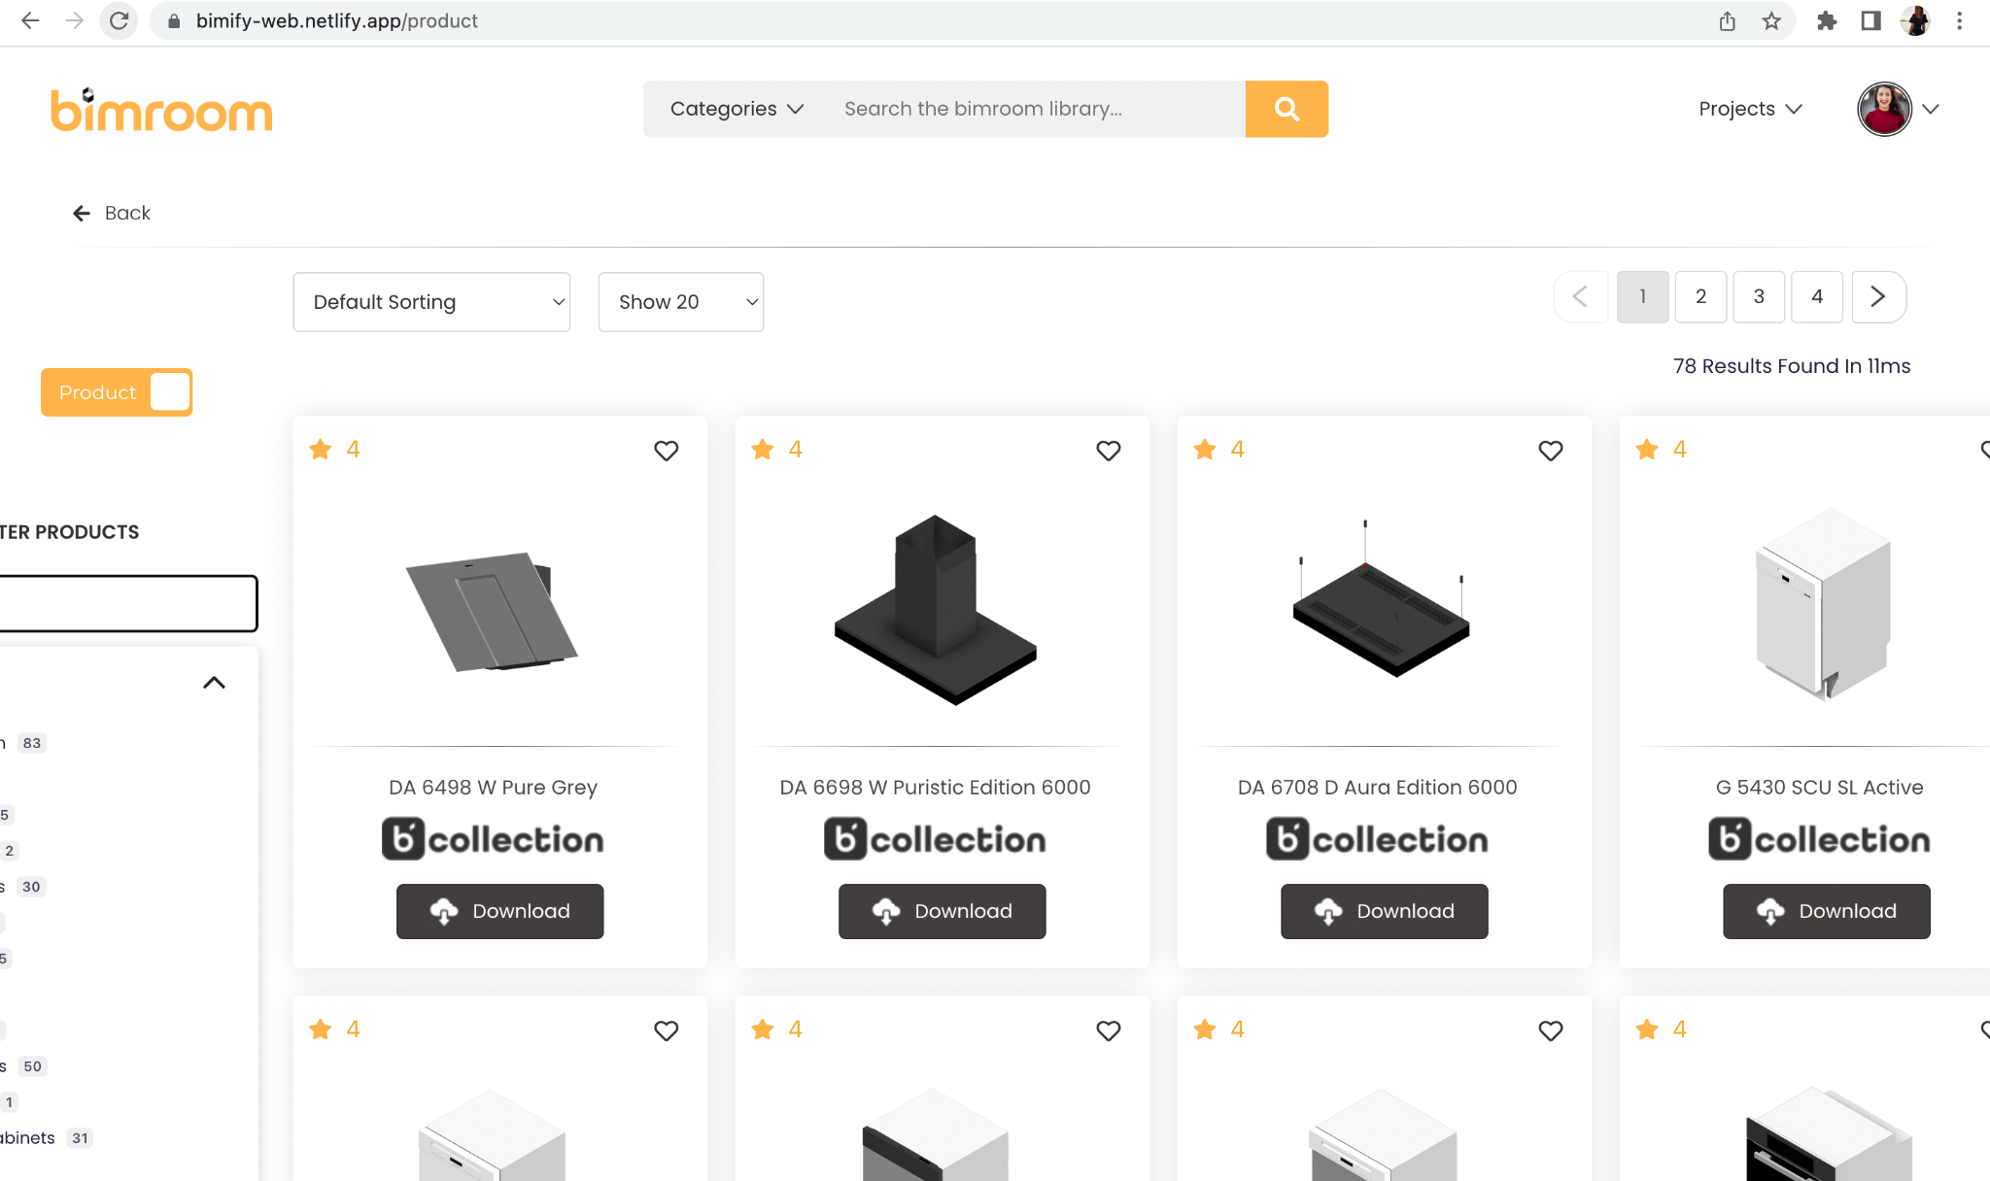23. When i open the library window on my macbook it scales it wrong and it cuts the left side drop down menus off.

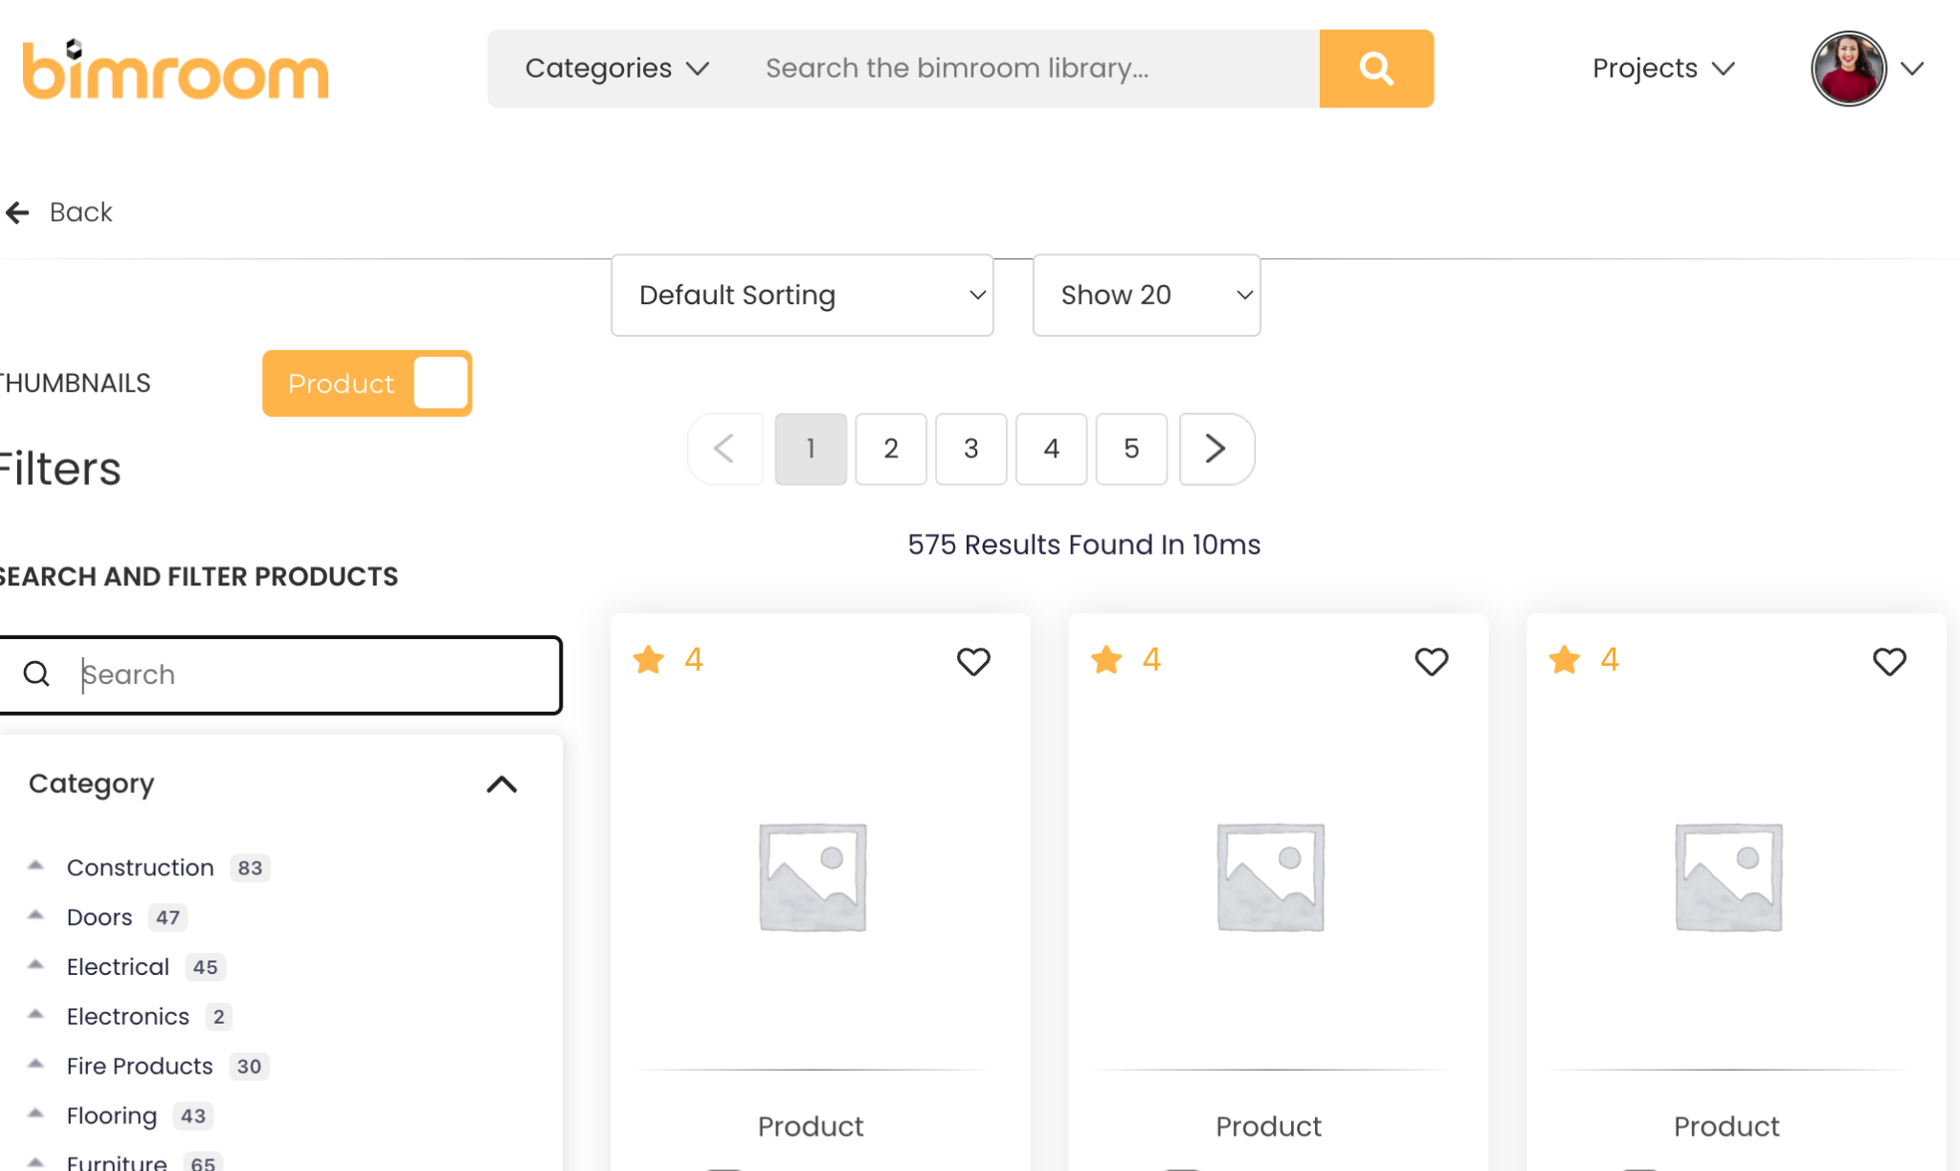

24. When I scale to half the size of my mac book screen the *Default Sorting* menu and the *Show* menu are placed in a weird spot and it lookes cramped with the menu underneath.

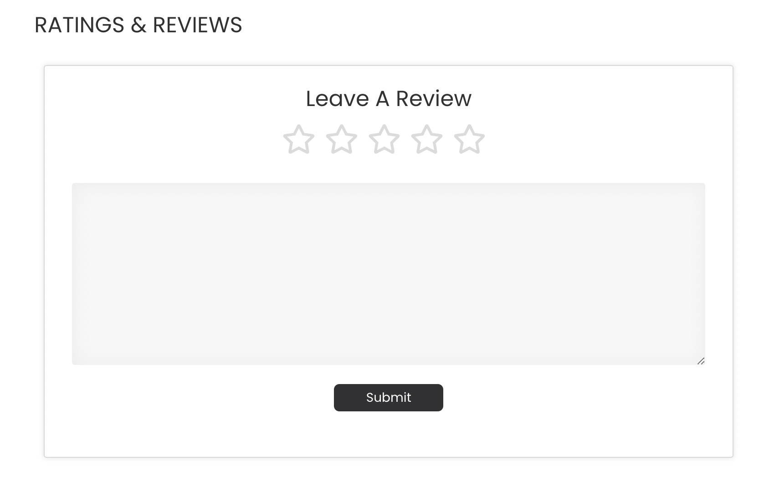

25. When I sent a review and pressed submit I got no confirmation that the review was sent. Here a pop-up window with “thank you for the feedback” or something like that would be good.

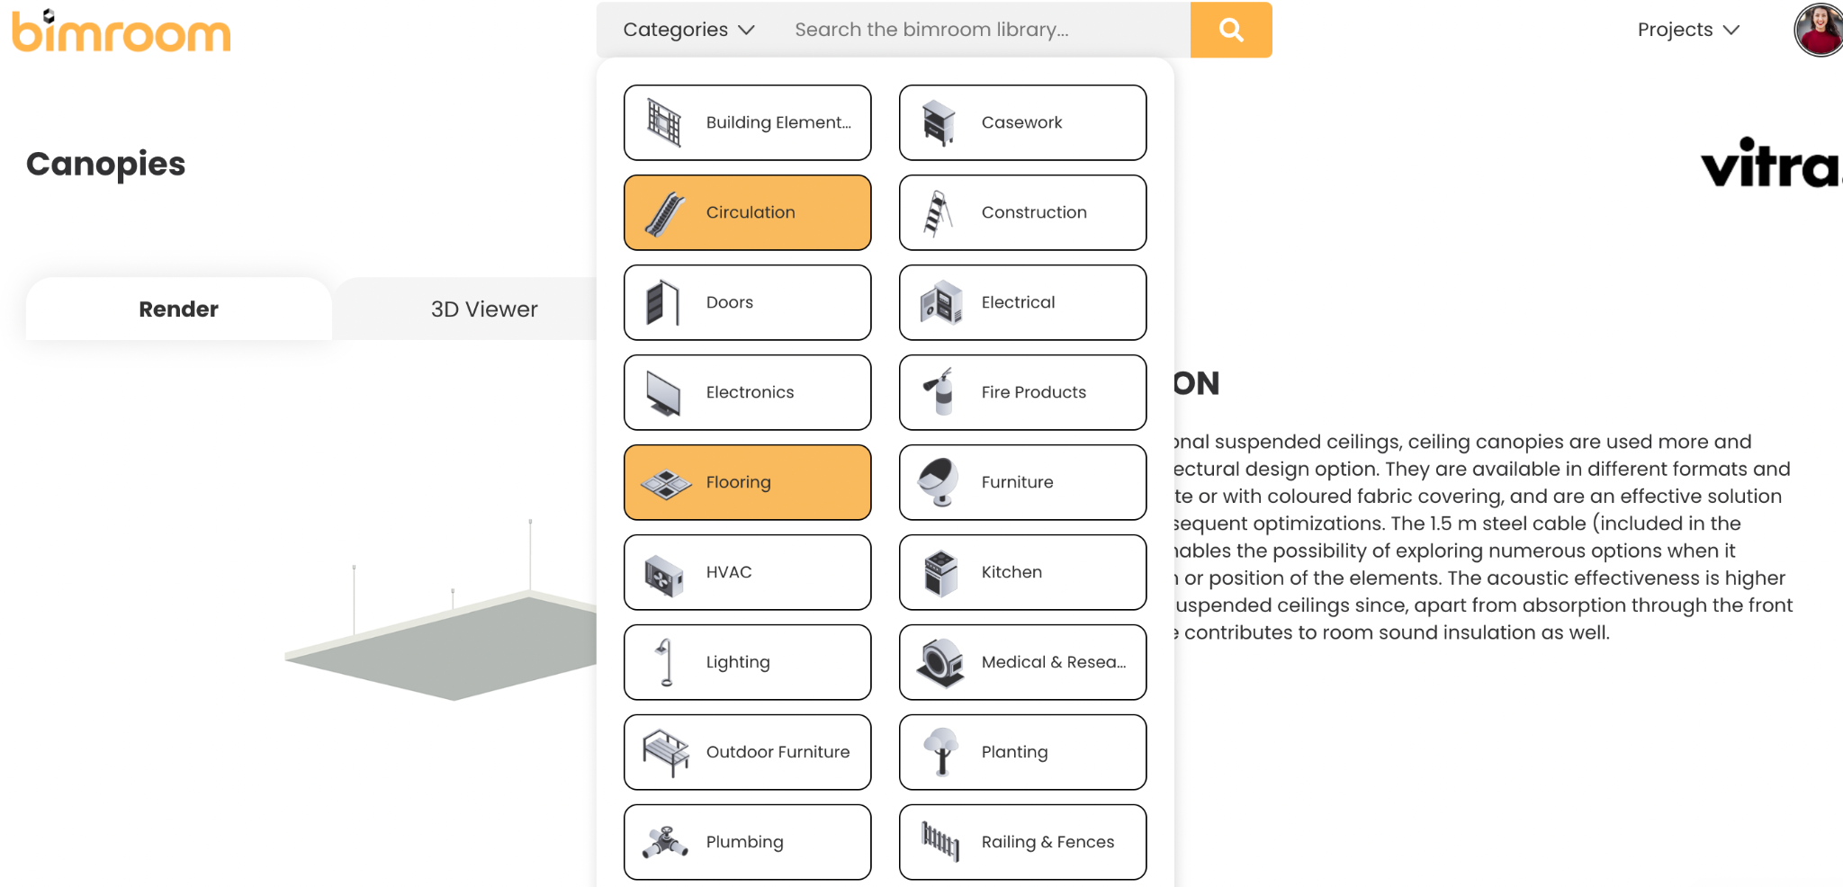

26. When I am on the product page of any product and I want to search for different things from the categories drop down menu, I can not access them. Nothing happens when I press them and this frustrating.

-> Check the original figma – chosen category should be visible instead of the “Categories” text in the dropdown

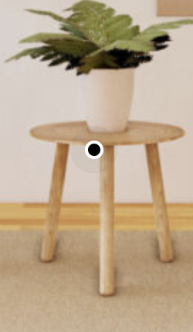28. This little dot indicator has no function. The others work when you hover on them but this one for the plant table doesn’t.

30. All products have 4 stars?